AWS

The different aws resources that will be used are

1.**EC2**

**2.RDS**

**3.VPC**

**4.ELB**

**5.SQS**

**6.EBS(ELASTIC BLOCK STORAGE)**

**7.AMI**

**8.AUTOSCALING**

**9.S3**

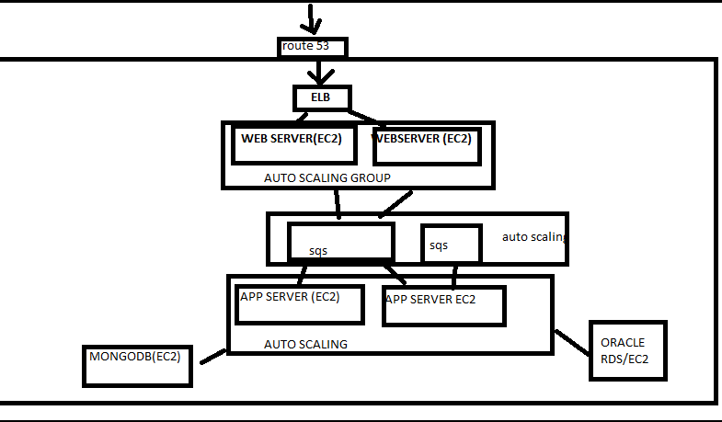

**I have attached a architectural diagram above**

**Route 53**

We need to use route 53 to route the url address to the ip address of the instances

**Web/app tier**

We need to use **elastic load balancer** to route the request to different **web servers** and for high availability and we will take care that there are different availability zones being used .

Also we can use autoscaling as it gives us greater redundancy against failure

**Oracle (rds/ec2)**

We can use oracle on either ec2 depending on the requirements of the application

**Oracle on Rds**

RDS provides lot of benefits such as

Automatic minor updates

Not required to manage underlying operating system

Multi-az

Automatic recovery in event of failure

Database size are less than 6 tb and maximum provisioned Iops are less than 30000

**Oracle on ec2**

If database sizes are large more than 6 tb and Iops can be greater than 30000

Also not all oracle features are supported in rds such as RAC, dataguard

**SQS in place of active mq**

1. SQS is a managed service. So you don't have to worry about operational aspects of running a messaging system including administration, security, monitoring etc. Amazon will provide support if something were to go wrong.
2. SQS is Elastic and can scale to very large rate/volumes